**Asian Ventures in New York**

Jinyuan Ng

31 May 2020

1. **Introduction**

Background

New York (NY), is the most populous city in the United States. With an estimated 2019 population of 8,336,817 distributed over about 302.6 square miles (784 km2), New York is also the most densely populated major city in the United States. NY also boasts being the Top 7th Most Visited City in the world, receiving 13.6million international visitors in 2019. This fact alone is enough to entice investors from all around the world to invest in NY, being opening a business or in real estate etc. However, it may seem daunting for Asian investors, as it’s hard to predict which of the major 5 boroughs should they open their business in or which area for property investments. Therefore this dataset would be advantageous for them, to predict which borough and their respective neighbourhood would welcome their business as compared to the rest. Using Foursquare API, I’ll create a map based on each borough with chosen locations as map markers.

Aims

This project aims to predict the top common venues within each borough, as well as consumer’s expenditure preferences.

Stakeholders

Asian investors who’s keen to venture into a business/ invest in NYC, as well as Asians who are planning to visit / migrate / study in NYC.

1. **Data Acquisition and cleaning**

Data Acquisition

I made use of Foursquare API to obtain coordinates of the respective boroughs, their respective neighborhoods and their common venues. I also obtained graphs from NYC Travel & Tourism Report 2019 to understand NYC consumers more as well as statistics of international tourists coming into NYC.

Data Cleaning

It would be too much of a hassle to go through all the common venues per neighborhood, so I decided to find the top 5 common venues per neighborhood first, before consolidating only the neighborhoods which has a Asian restaurant / business in the top 5 common venues per borough. Therefore, it’d be easier for investors to see in a glance how welcoming of the neighborhoods would be with their businesses.

1. **Methodology**

Using the Foursquare API, I set the limit of number of nearby venues to 100, within a radius of 700m from the centres of each Boroughs, and then compile the top 5 common venues into a data frame. I will use Bronx as an example.

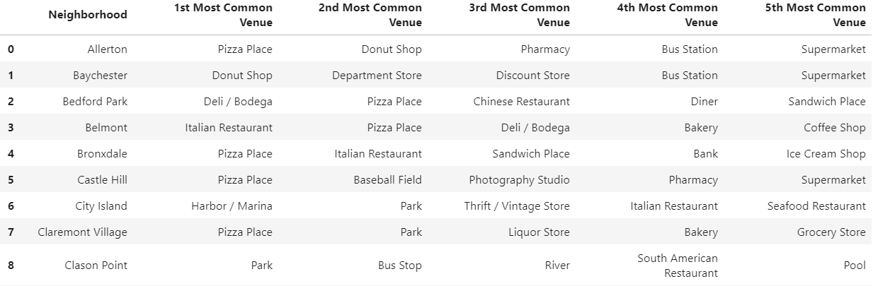

After which, I’ll locate the Asian restaurants and create a new data frame, only containing neighborhoods with Asian restaurants for each Boroughs. Then, I used the folium.Map function to plot a map with the selected neighborhoods as label markers.

Now, we’ll take a look at statistics on international tourists and their respective expenditures.

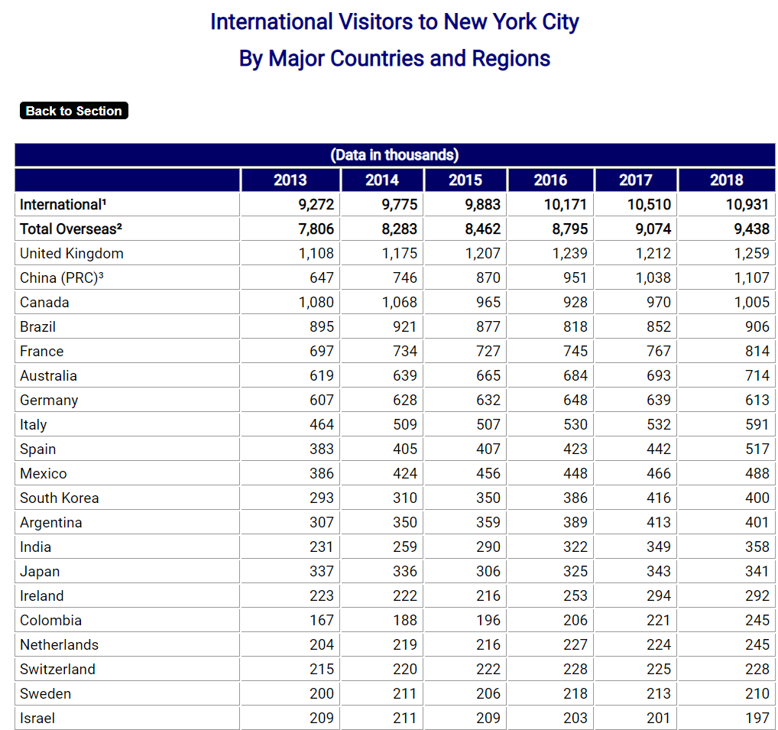

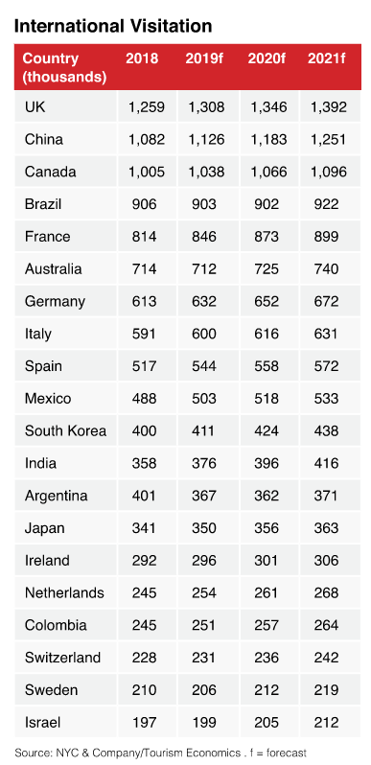

From above, we can observe that China, India, South Korea and Japan are the major 4 Asian countries. Currently, there’s a Korea Town as well as a ‘Little India’ at Manhattan, Chinese Restaurants made up 10% of the total restaurants in NYC just in 2009, and as of 2017, 20% of the Michelin Star Restaurants in NYC were Japanese Restaurants. This shows that there’s market and demand for Asian food in NYC.

Next, we’ll take a look at the distribution of tourist’s expenditure.

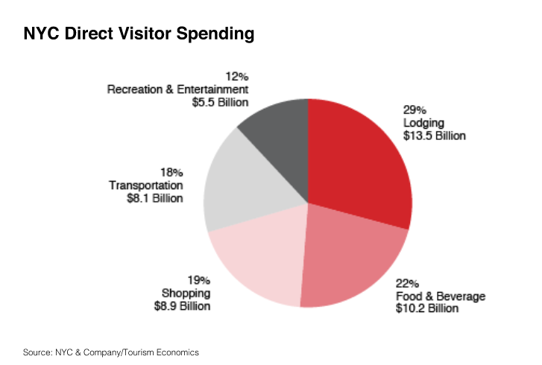

From the above diagram, we can infer that Food & Beverage, as well as Lodging make up more than half of tourist’s expenditure, which means it’d be lucrative to invest in either business.

1. **Results**

Now, we’ll take a look at the selected neighborhoods per Borough and their respective locations on the Map.

**Bronx**

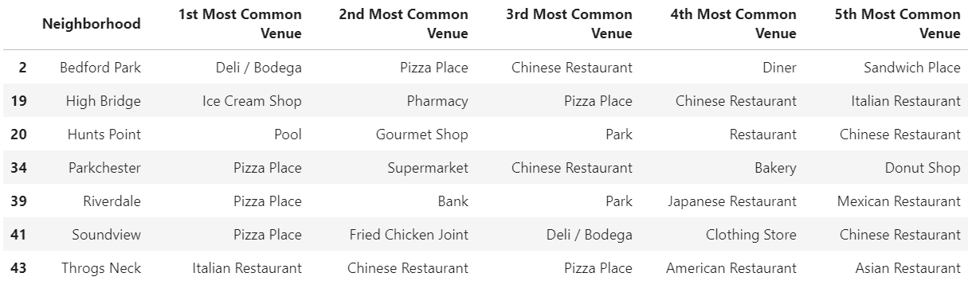

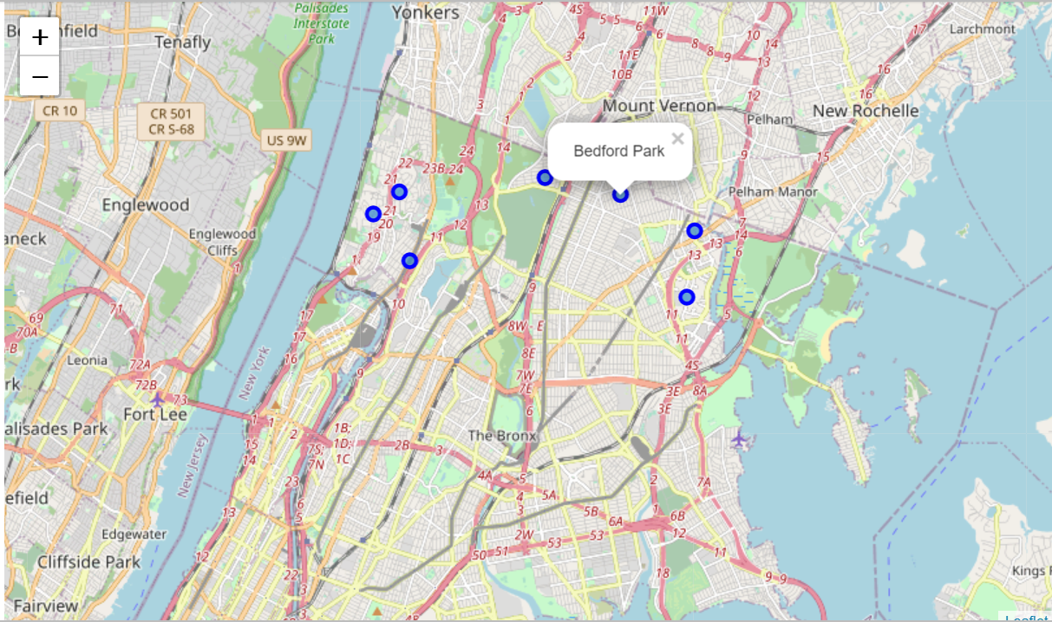

**Manhattan**

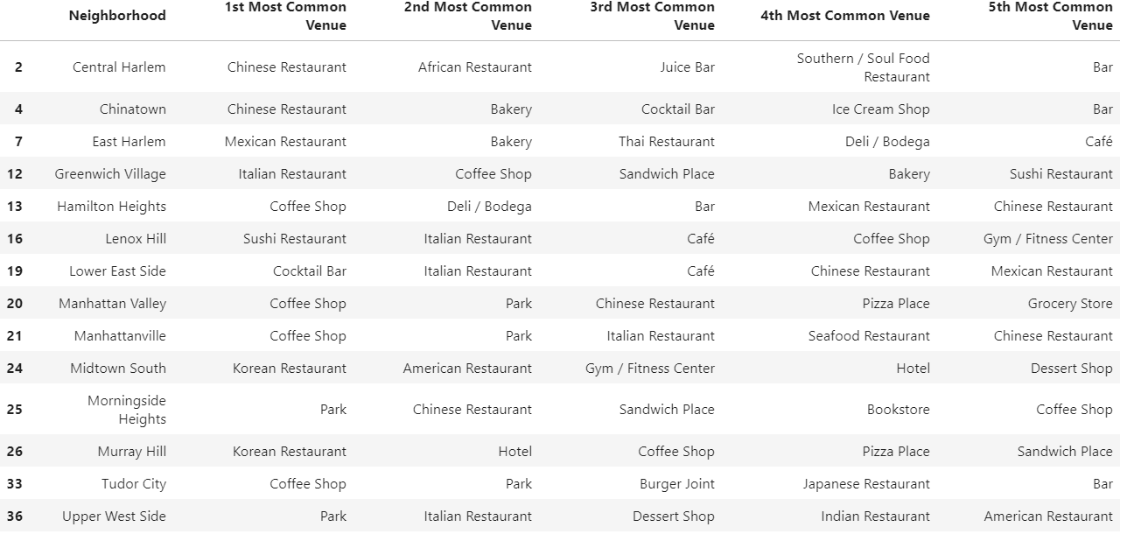

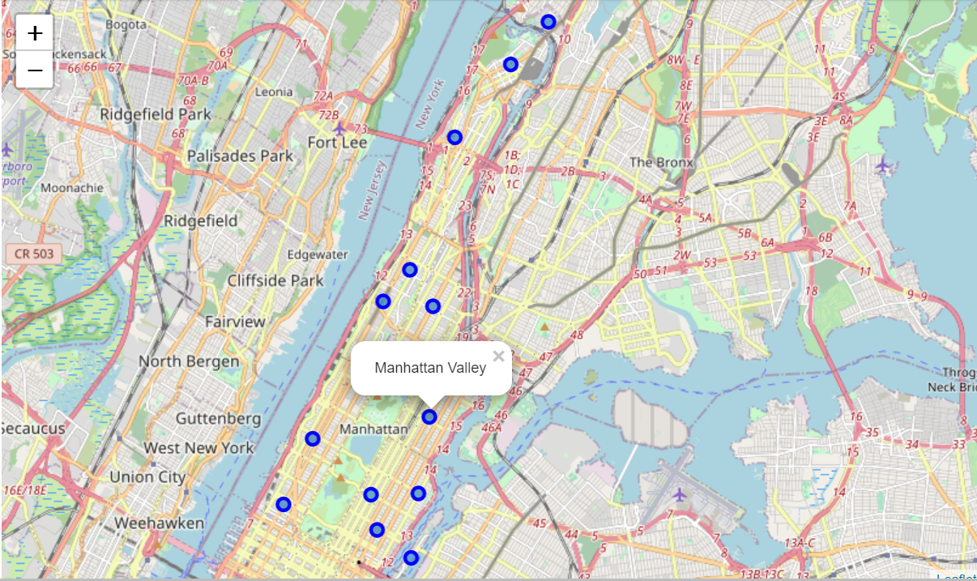

**Brooklyn**

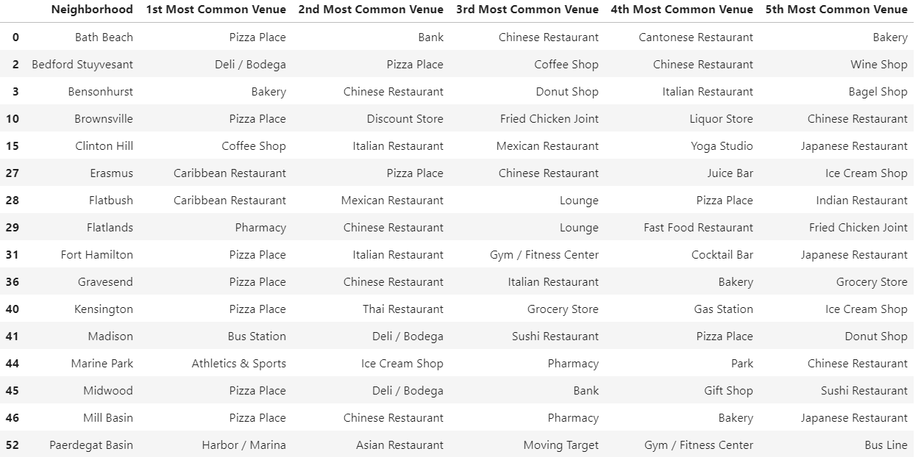

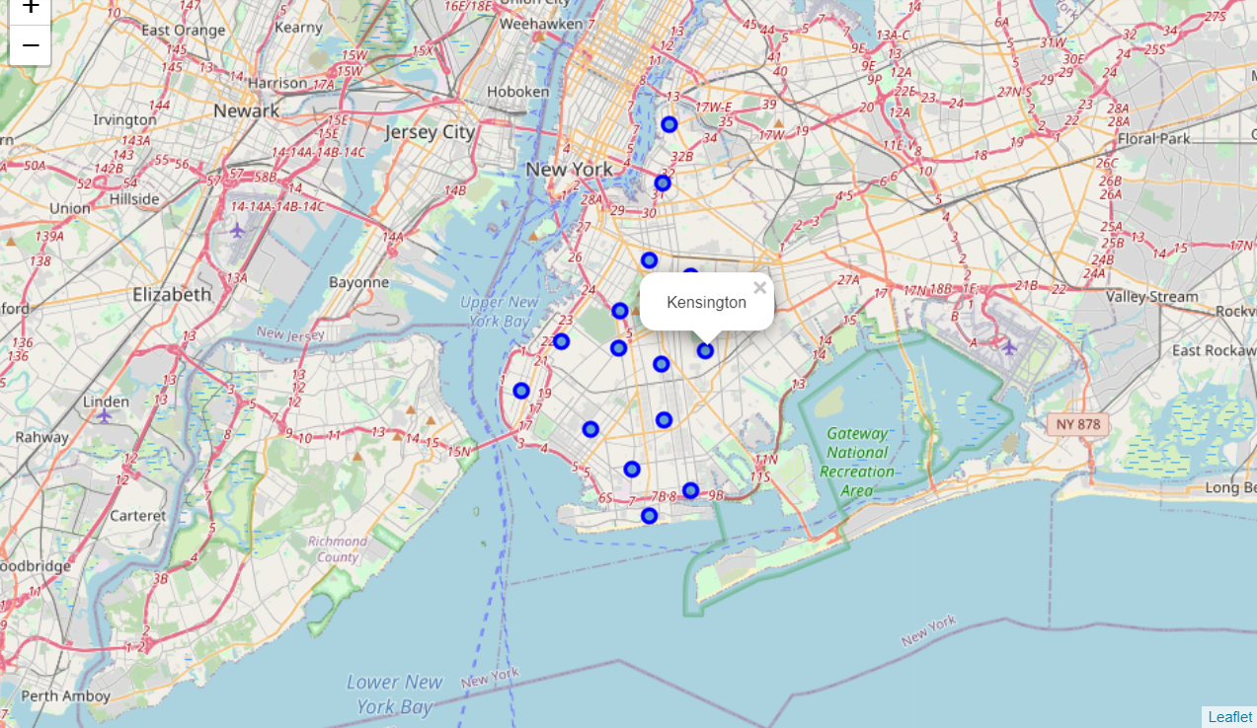

**Queens**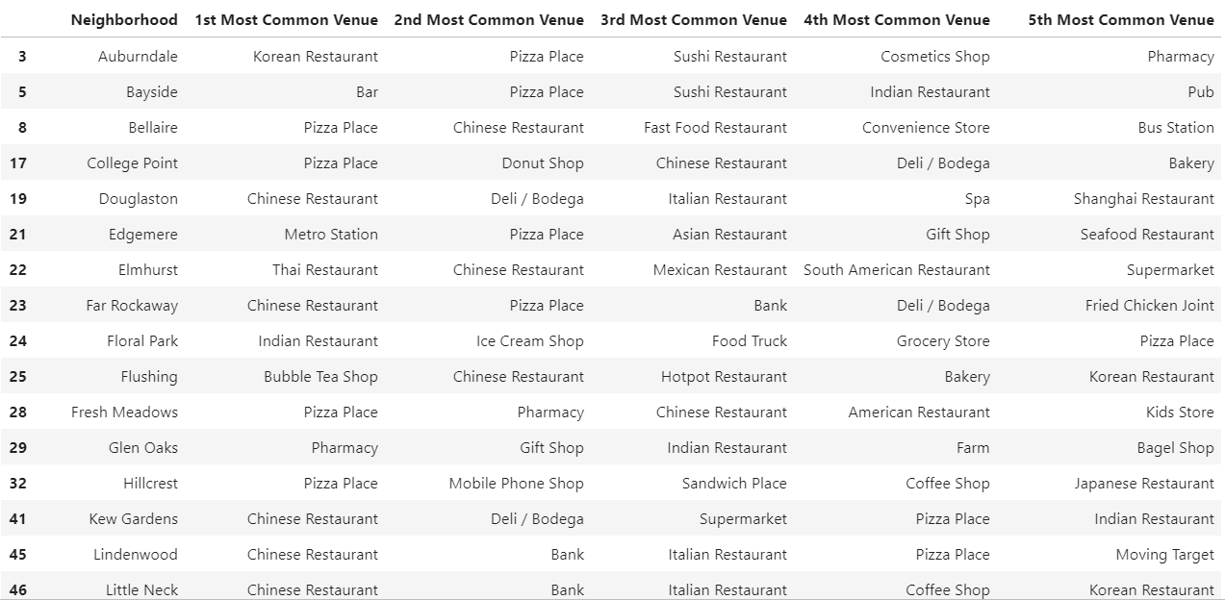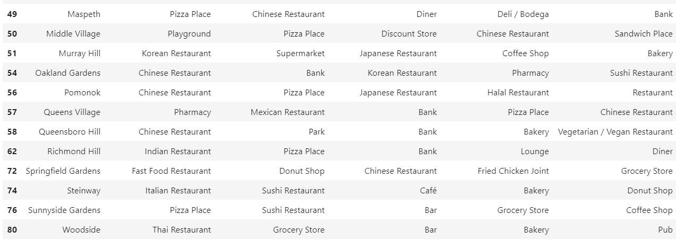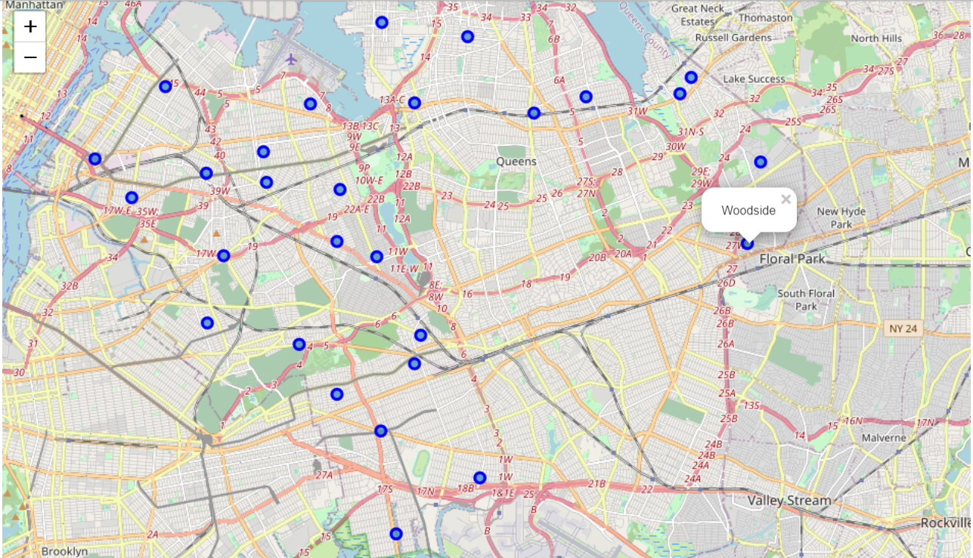

**Staten Island**

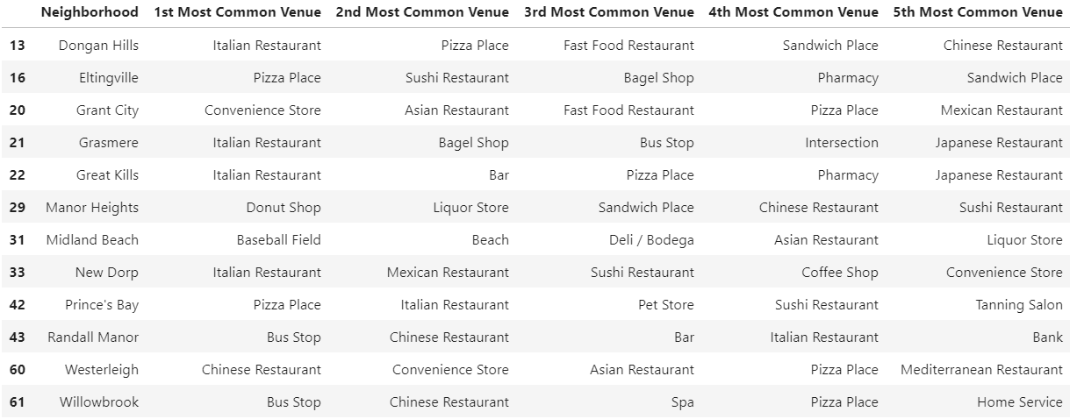

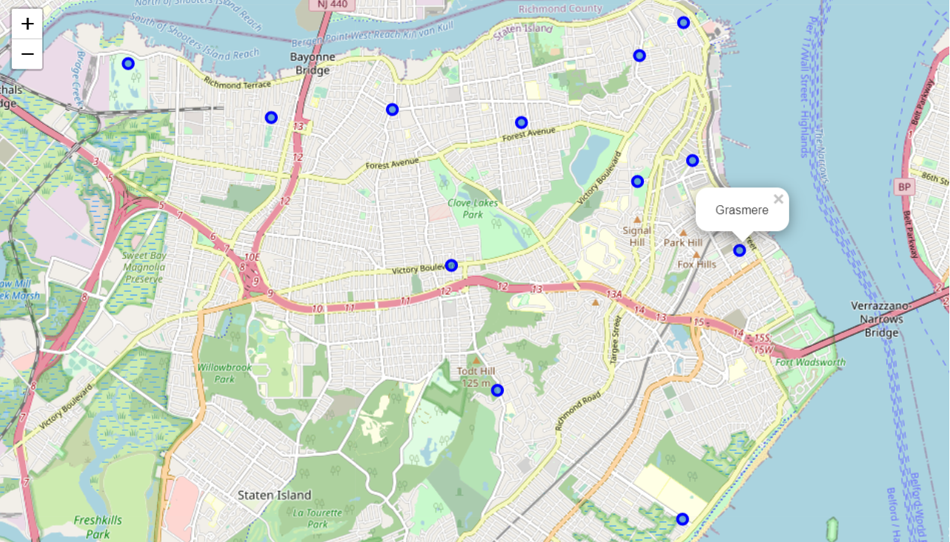

From the diagrams above, we notice that Queens has more Asian restaurants than the other Boroughs. Furthermore, from statistics in 2019, Queen also has the greatest profit compared to the rest.

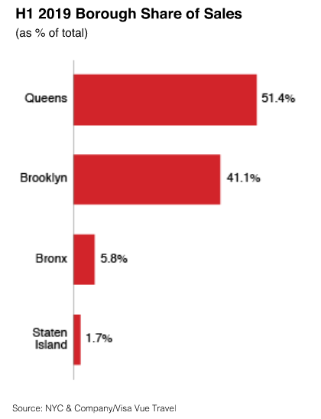

Lastly, we’ll take a look at the demographics for Lodging.

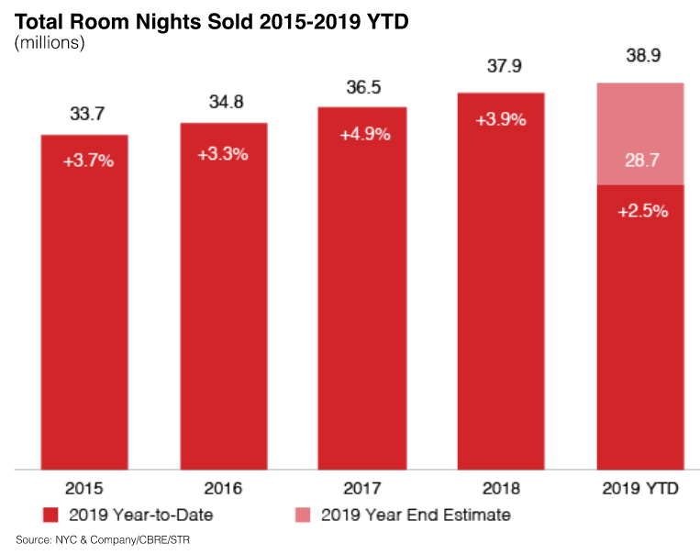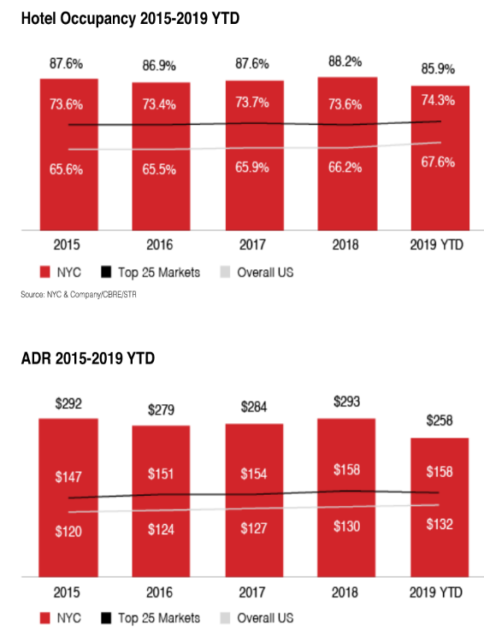

1. **Discussion**

I performed data analysis with the information found from Foursquare API and visualized the data via a data frame and its respective locations on a folium Map. Just from the above information, we could see that asides from the big 4 (Korea, Japan, India & China), there are also a few Thai restaurants. It’d be nice to see more of a variety, like Indonesian, Vietnamese cuisines etc. I also did some research online to observe expenditure preferences of tourists and NYC locals, and chose the relevant diagrams above for this project.

This dataset can also be expanded to fit in respective age population per neighbourhood in each borough or other variables investors might find important for their businesses.

1. **Conclusion**

I believe this dataset will be helpful for those who plans to bring over more Asian influences. I have also attached relevant links below such as rental pricing per neighborhood in each borough, social demographics per borough (Male, Female % etc), as well as NYC consumer expenditure.

Despite the situation now with COVID, I believe the economy will rebound back slowly and businesses will get back on track. Therefore investors should remain optimistic as well.

Table of References

1. New York City. Retrieved from (<https://en.wikipedia.org/wiki/New_York_City>)
2. Korea Town. Retrieved from (https://en.wikipedia.org/wiki/Koreatown,_Manhattan)
3. Most Visited Cities Around the World 2019 Retrieved from (https://www.businessinsider.com/most-visited-cities-around-the-world-ranked-2019-9#7-new-york-city-136-million-13)
4. Chinese Restaurants in NYC. Retrieved from (http://michaelminn.net/newyork/food/chinese-restaurants/)
5. Statistics of International Tourism in NYC (2013-2018). Retrieved from (https://www.baruch.cuny.edu/nycdata/tourism/international_visitors.html)
6. Travel and tourism trend report in NYC. Retrieved from (https://indd.adobe.com/view/e91e777a-c68b-4db1-a609-58664a52cffd)
7. NYC population statistics. Retrieved from (<https://www.citypopulation.de/en/usa/newyorkcity/>)
8. NYC rentals. Retrieved from (<https://comptroller.nyc.gov/reports/retail-vacancy-in-new-york-city/>)
9. NYC Japanese Michelin stars restaurants. Retrieved from (<https://www.cntraveler.com/story/new-york-city-michelin-starred-japanese-restaurants>)
10. Indians in NYC. Retrieved from (<https://en.wikipedia.org/wiki/Indians_in_the_New_York_City_metropolitan_region#Cuisine>)
11. NYC consumer expenditure statistics as of 2017. Retrieved from

-(<https://www.baruch.cuny.edu/nycdata/consumer_prices/annual_exp-categories.htm>)

-(<https://www.bls.gov/regions/new-york-new-jersey/news-release/pdf/consumerexpenditures_newyorkarea.pdf>)